# Quick translations

Firstly ensure you have installed the google translate python api library in your environment:

Pip install googletrans

Save the translate.py on your local machine

Create a .txt file in with your list of terms to be translated on each row e.g.

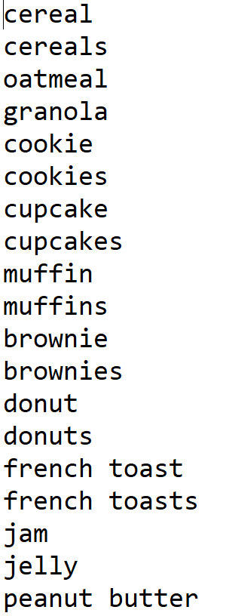

Run the translate.py file

Python translate.py

A dialog box will open to allow you to select your text file containing your terms to be converted, select your file.

Enter the code to tell it what the original language the terms are (see this list if unsure XXXLINK)

If unsure, type auto and the system will try to automatically recognise the source language

When prompted, enter the code of the language you want the terms to be translated into (use same list as above)

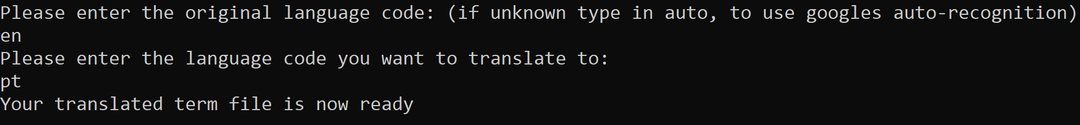

If correctly entered, the script will translate the terms and create a .xlsx file in the same folder displaying the original terms and their translated version, the filename will be suffixed with the destination language code. (see example output below)

